Finding the truth in a virtual courtroom:
Criminal trials in Indonesia during COVID-19

(supplementary files)

SURVEY FORMS.

https://docs.google.com/forms/d/1ugJa9B694Sm6AF0uruHNydCuc2-e5L-EYkIUvgRG70c/edit?pli=1

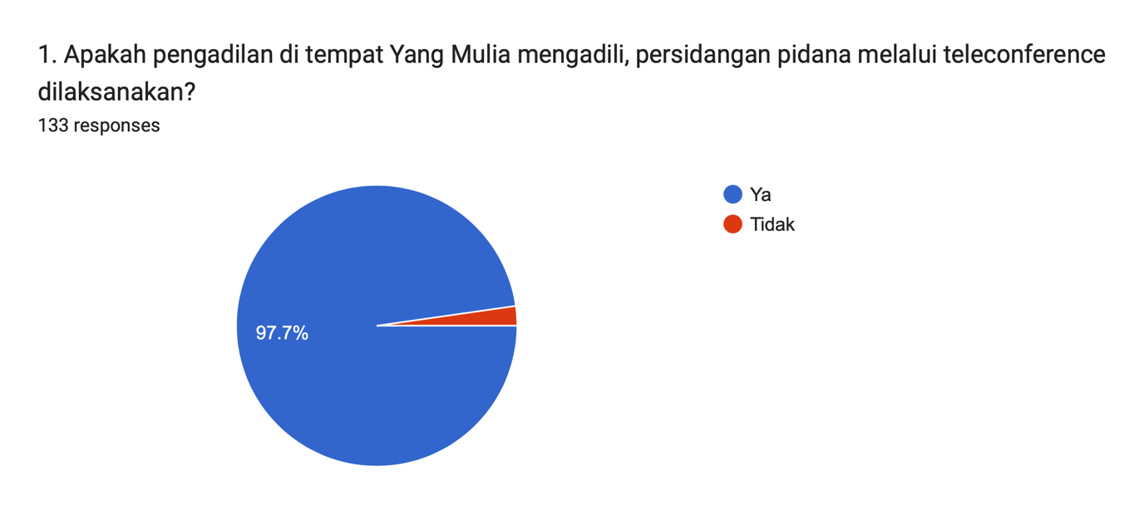

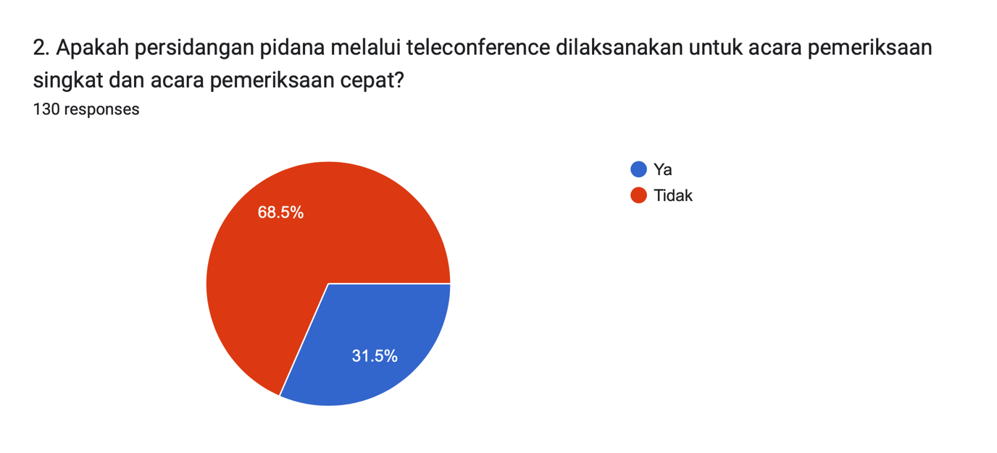
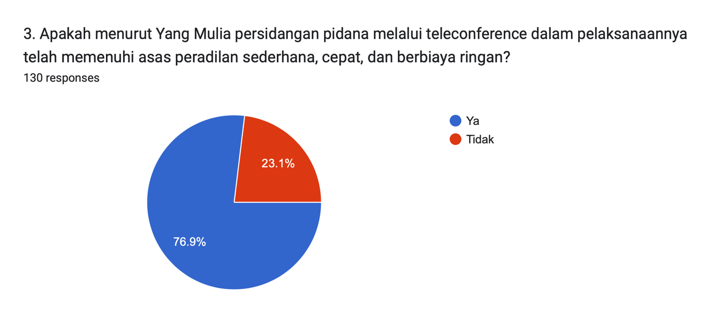
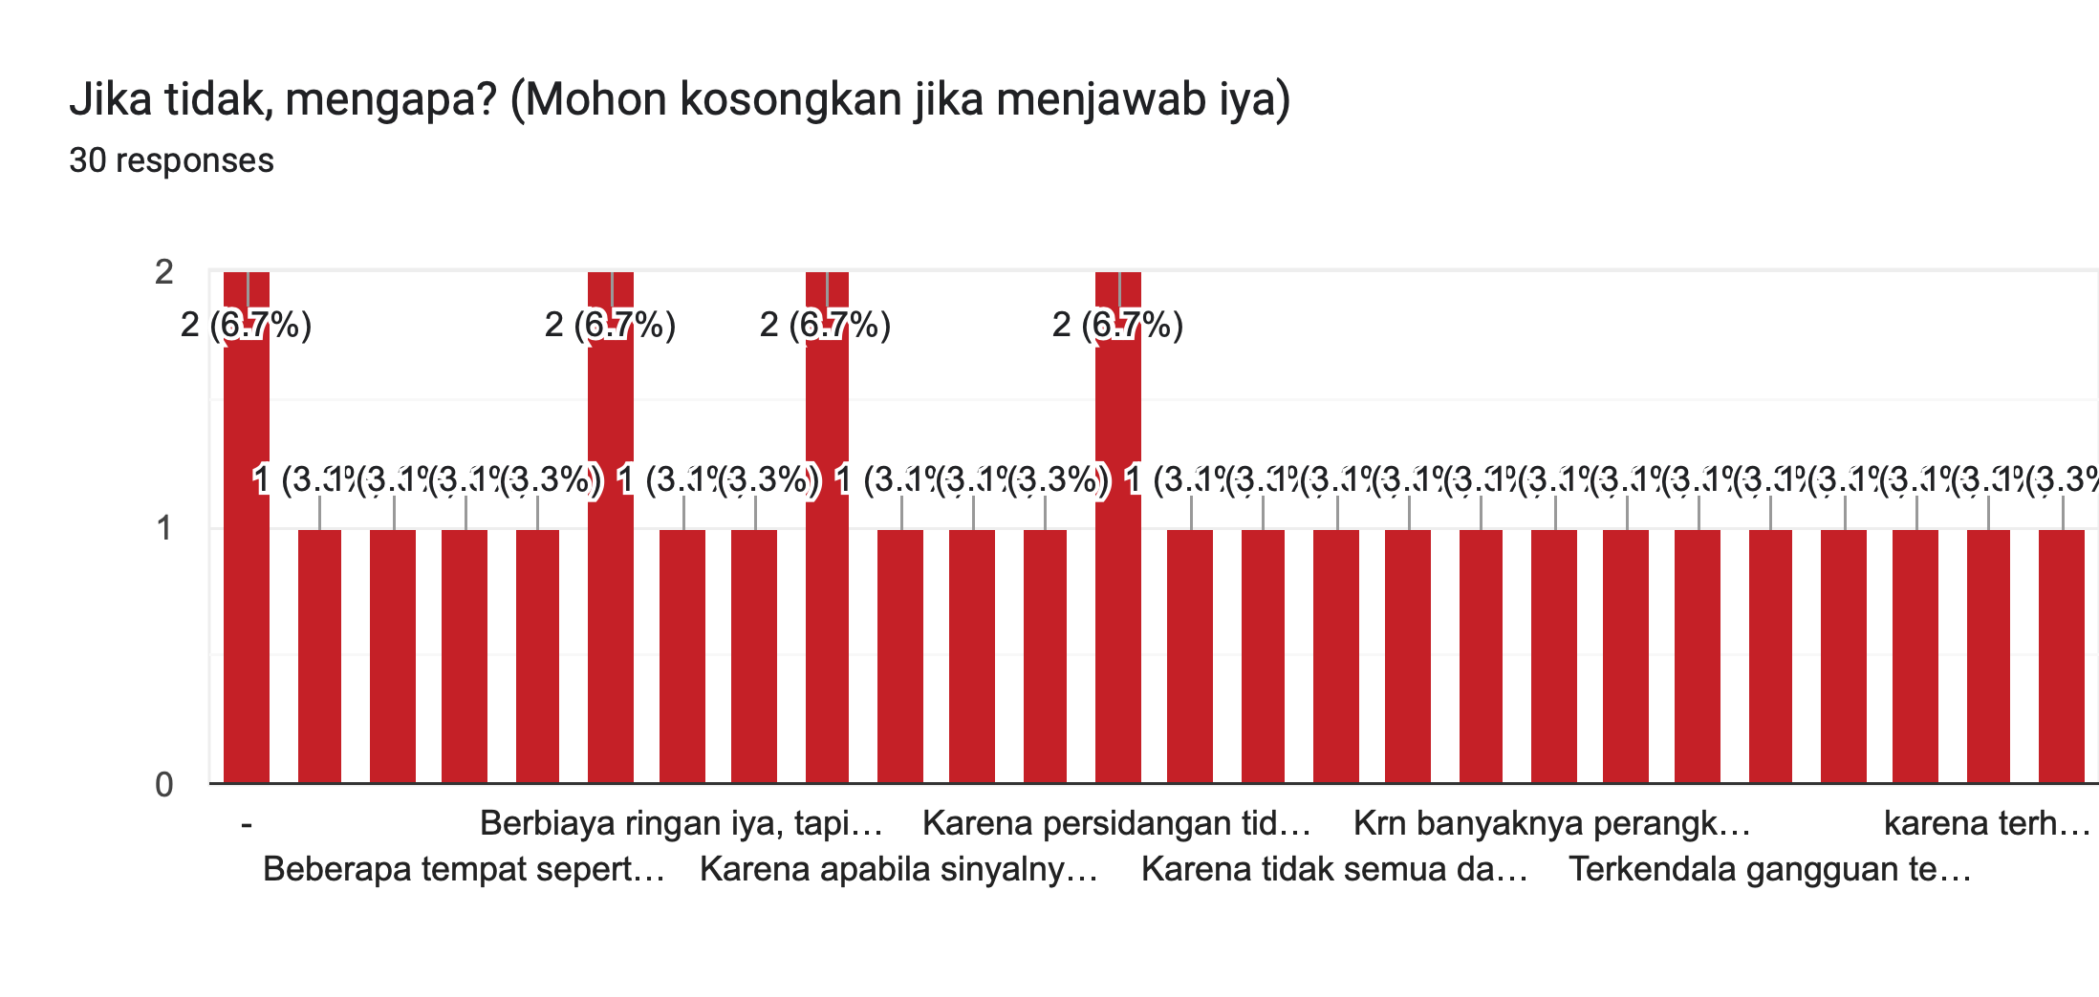

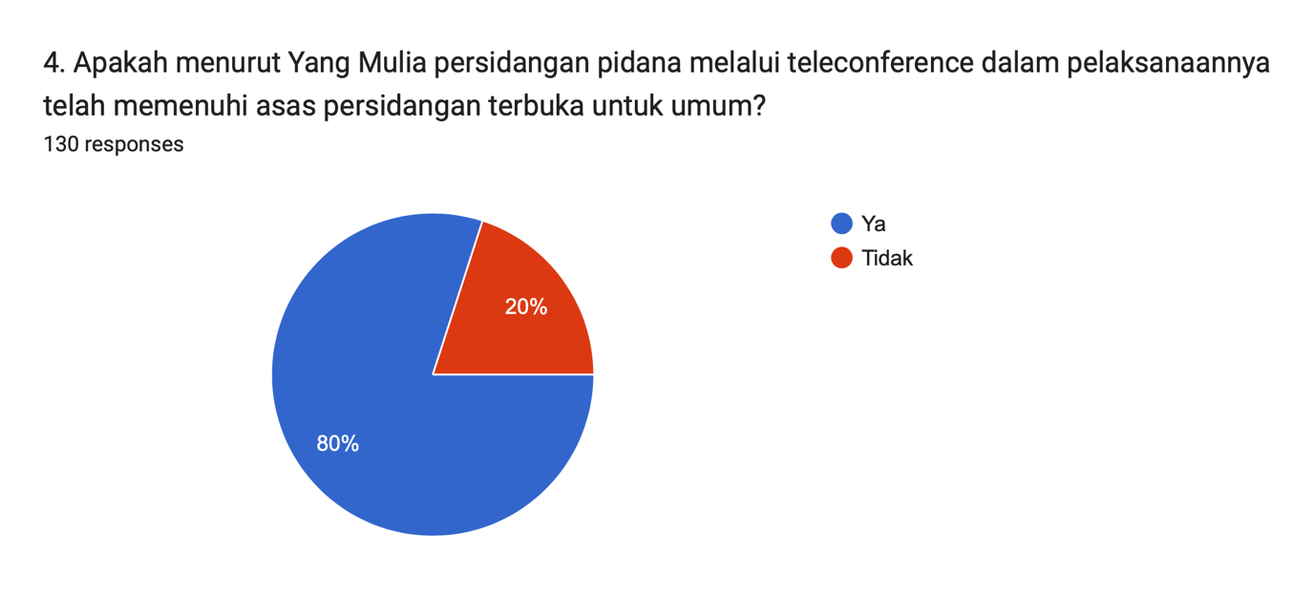

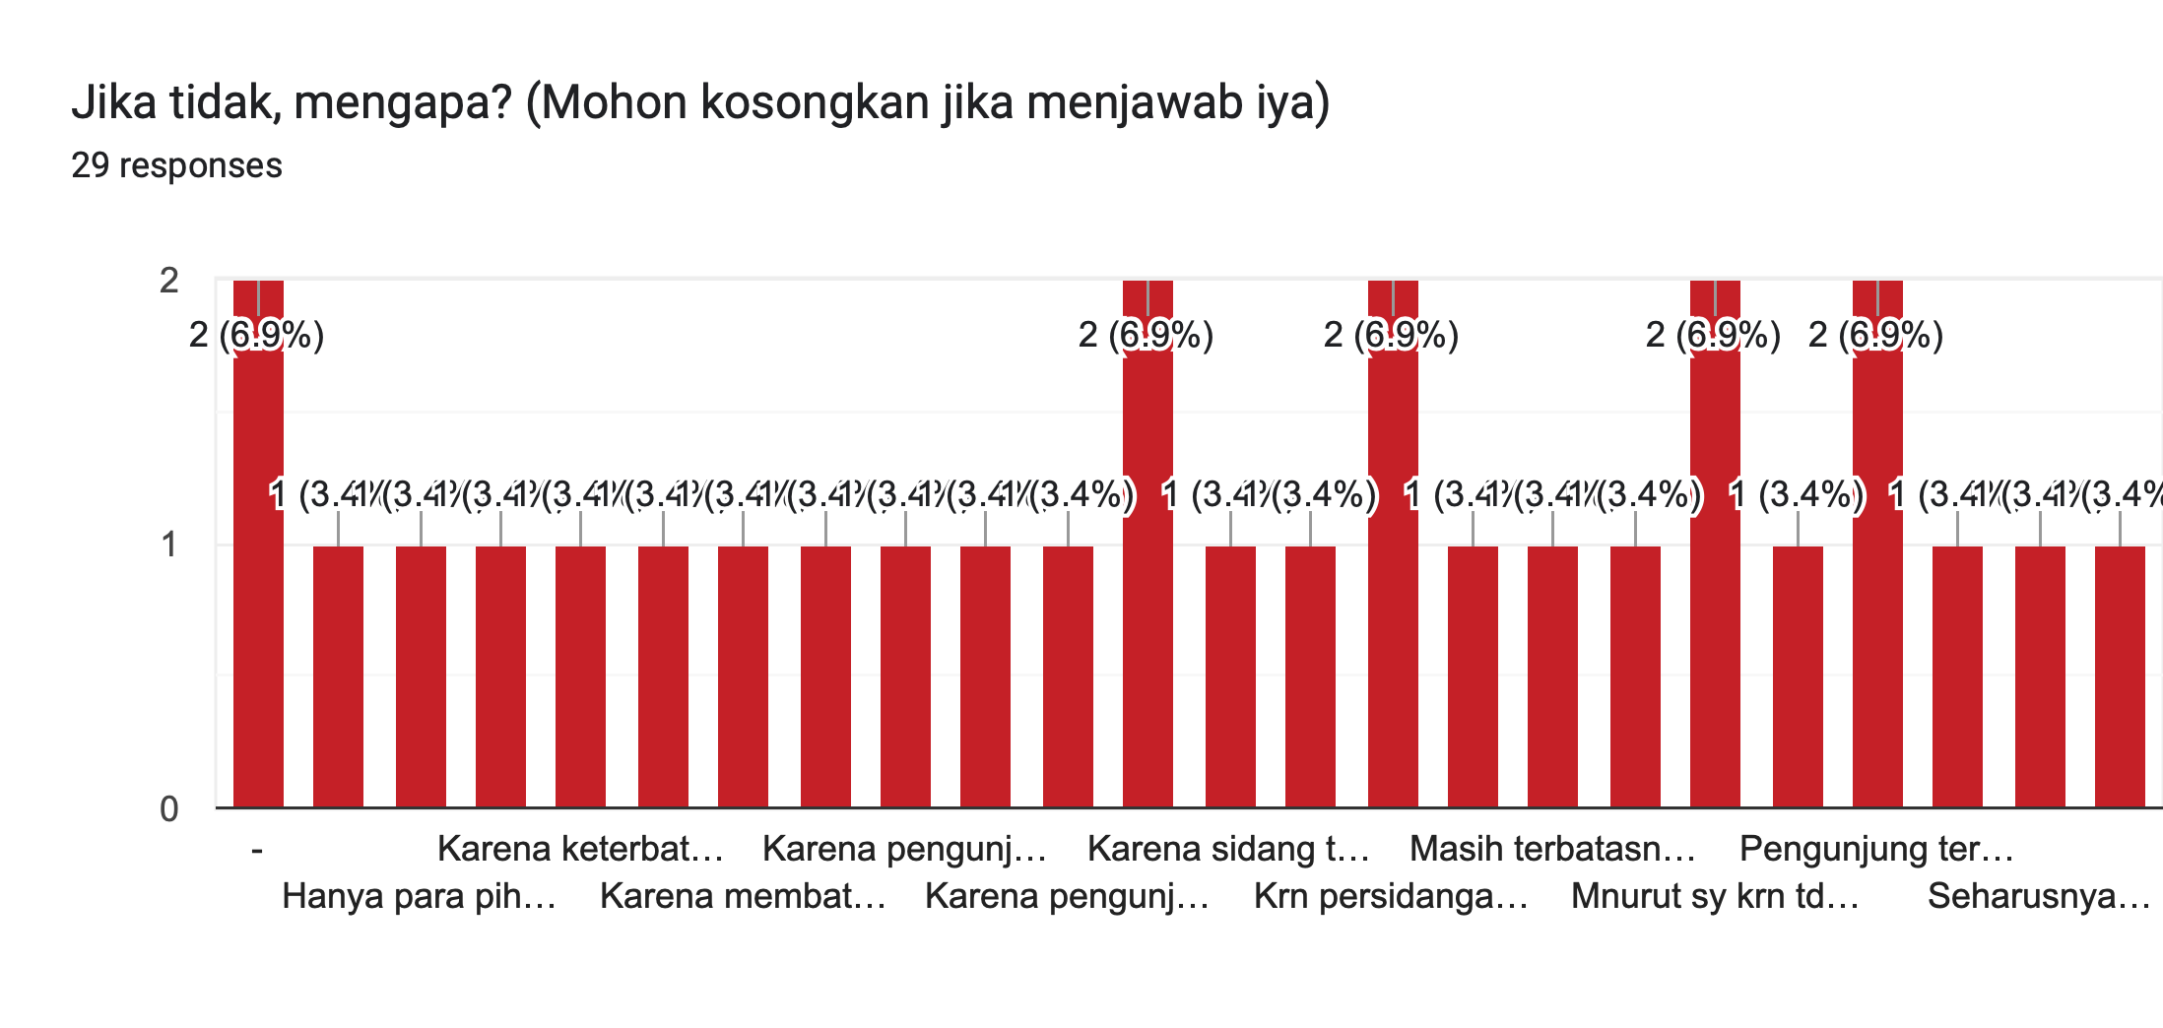

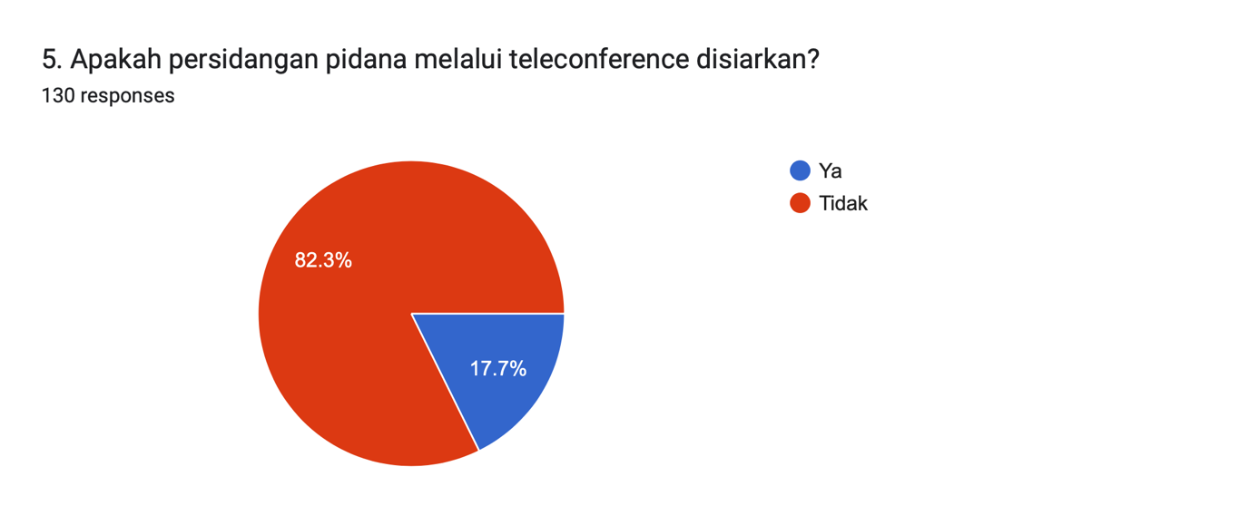

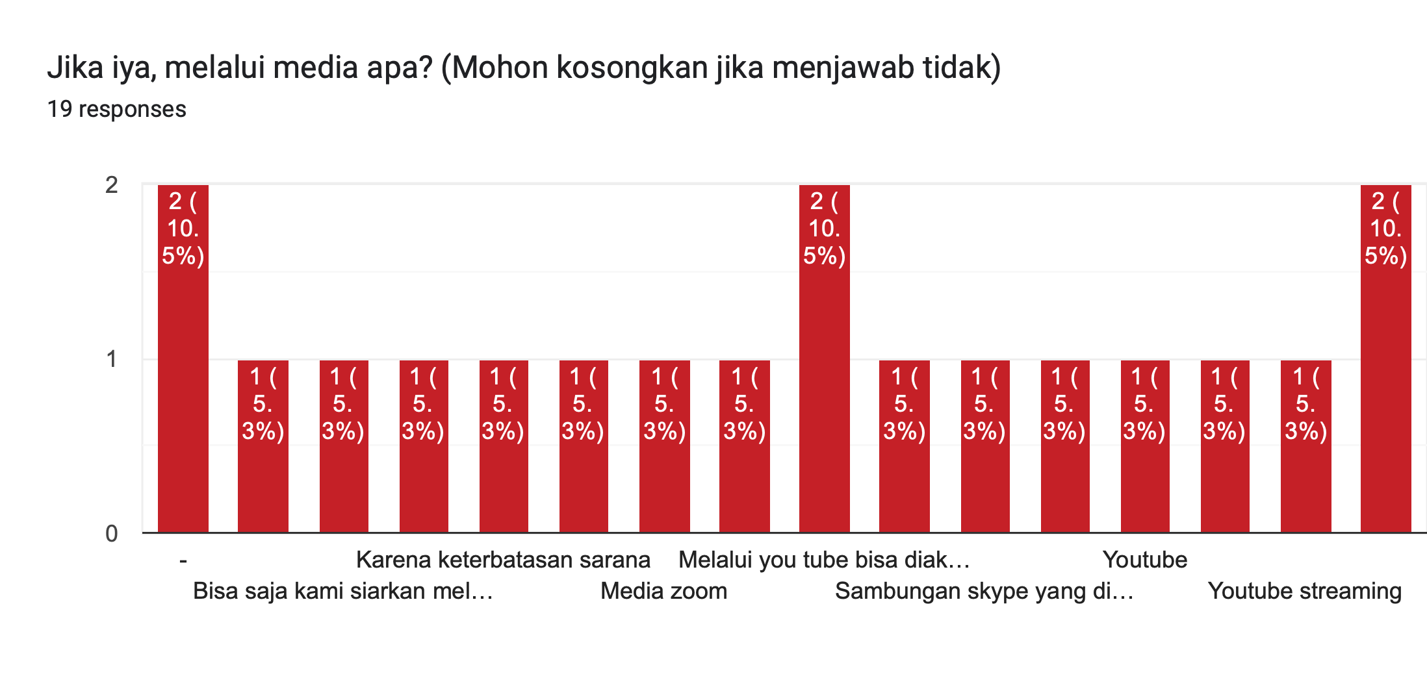

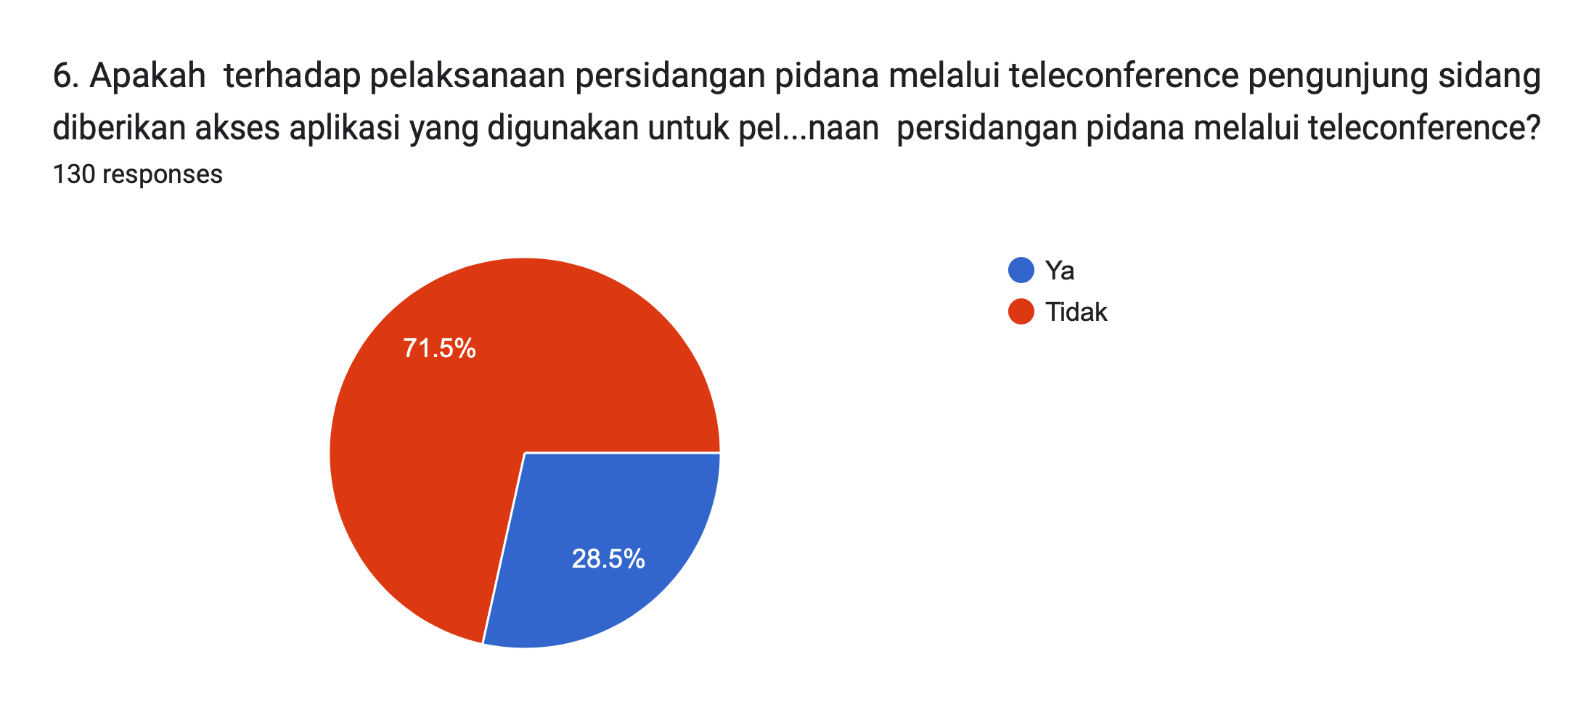

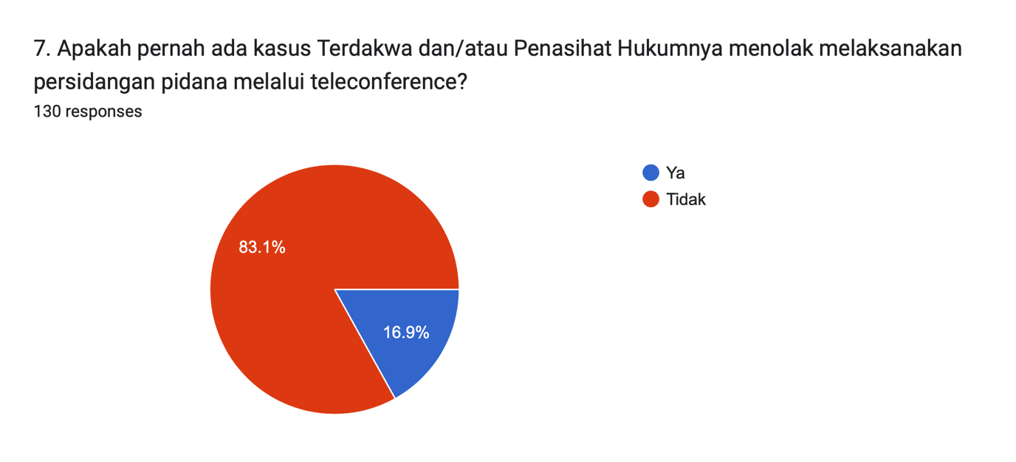

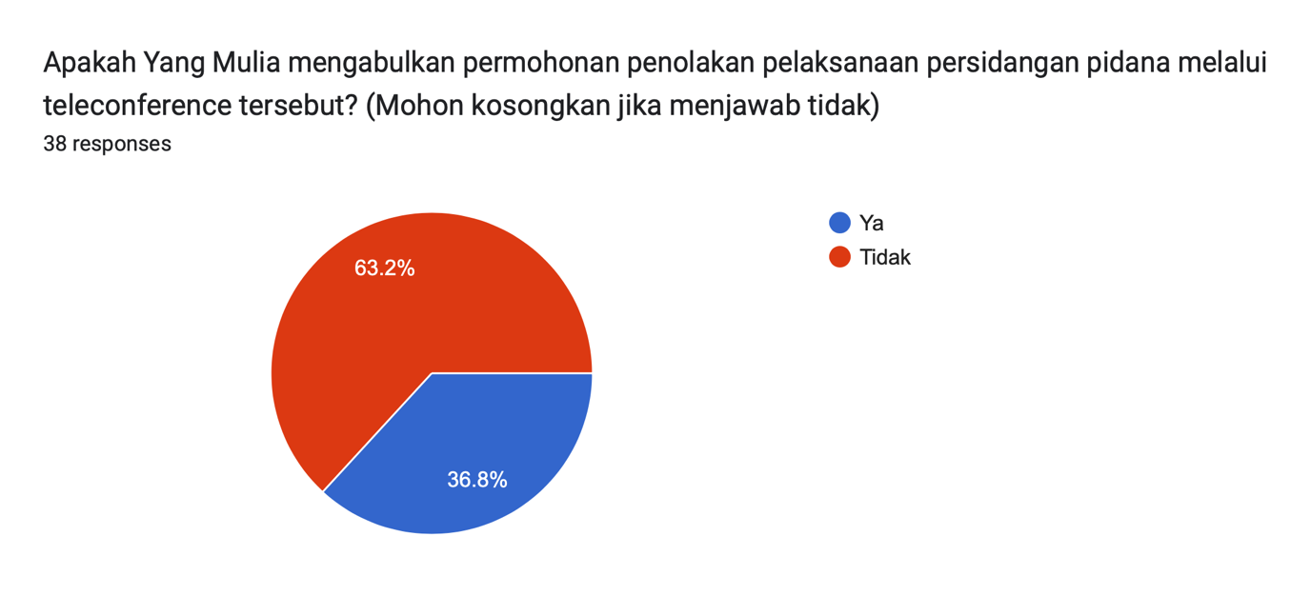
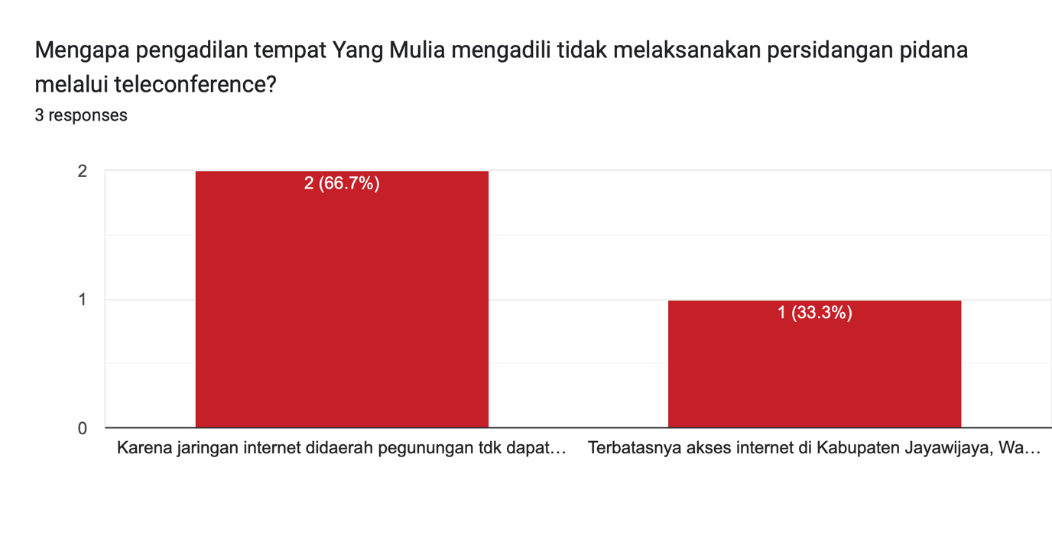

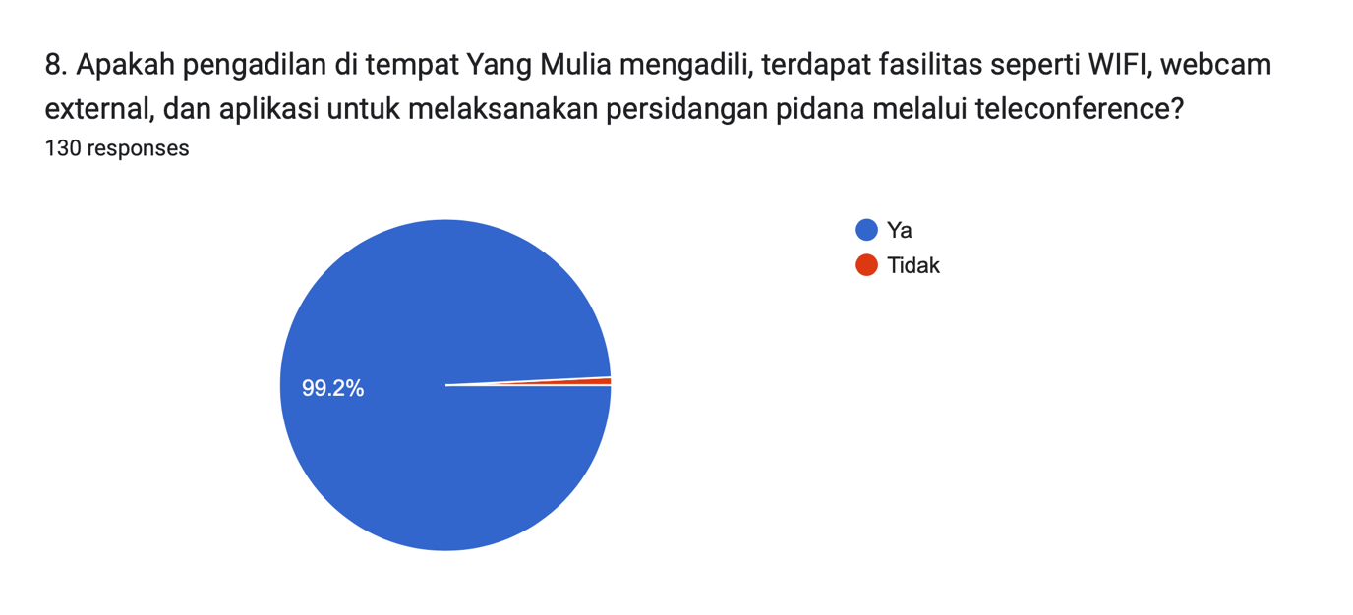

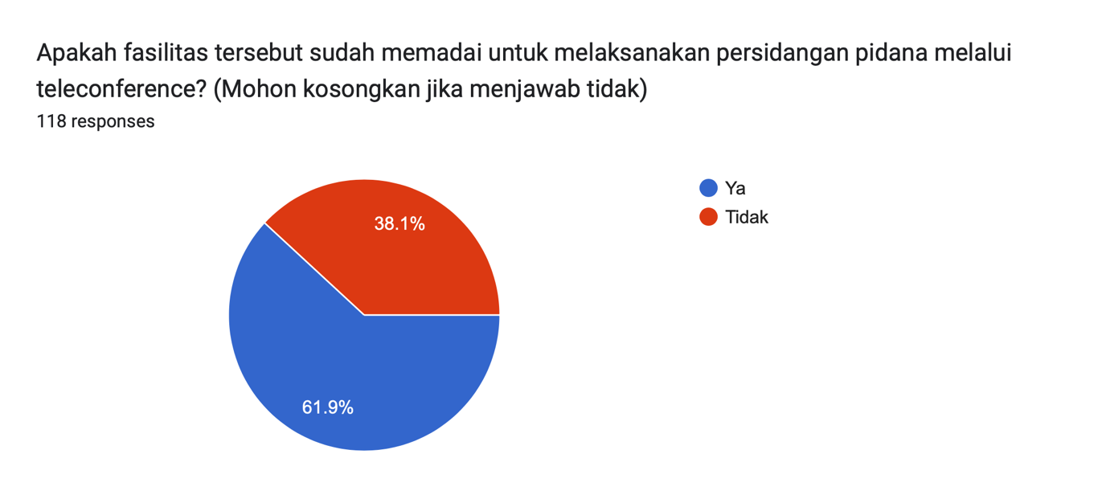
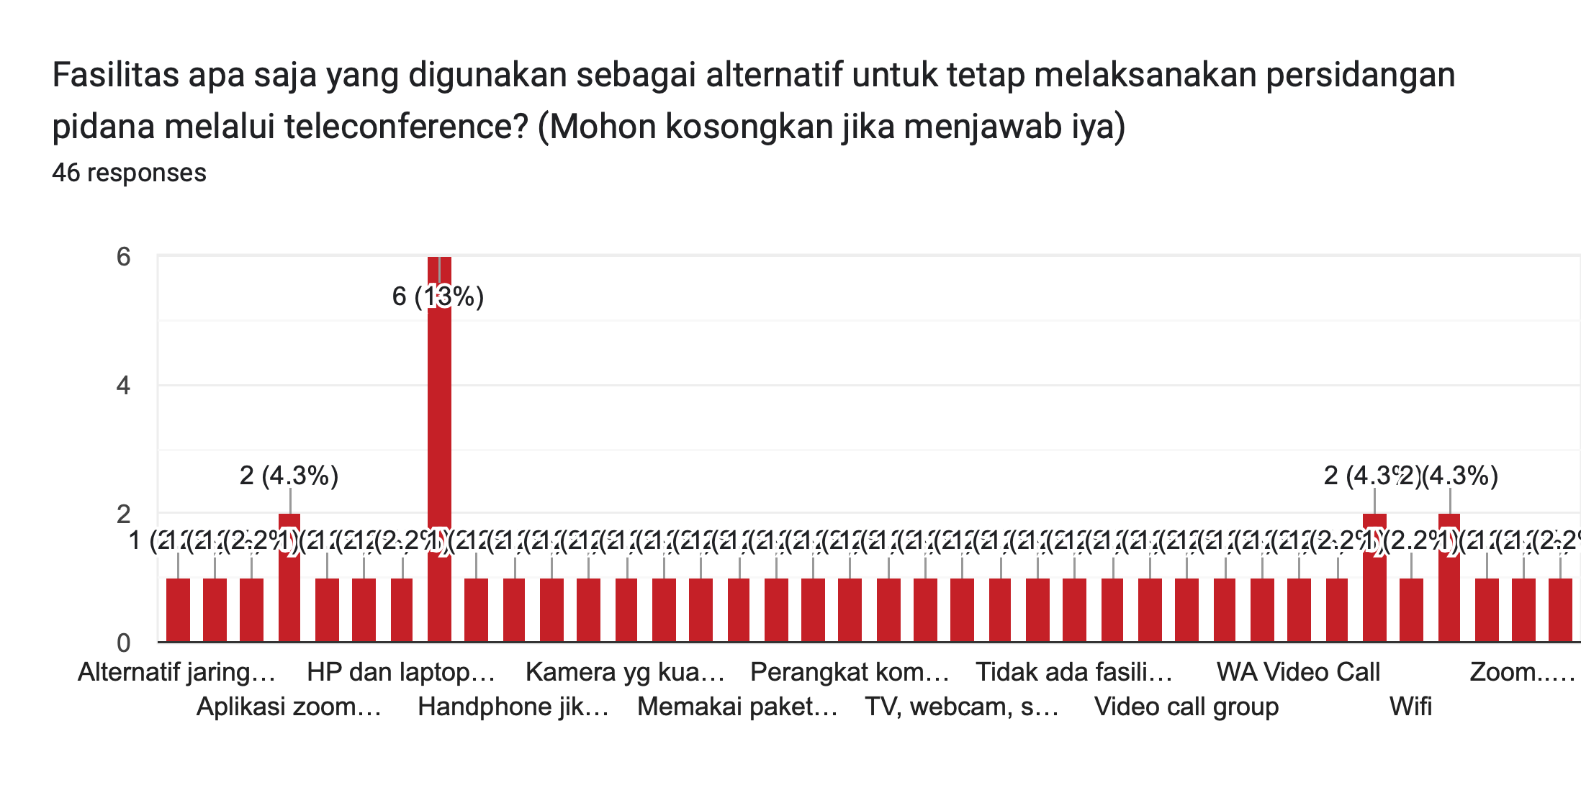
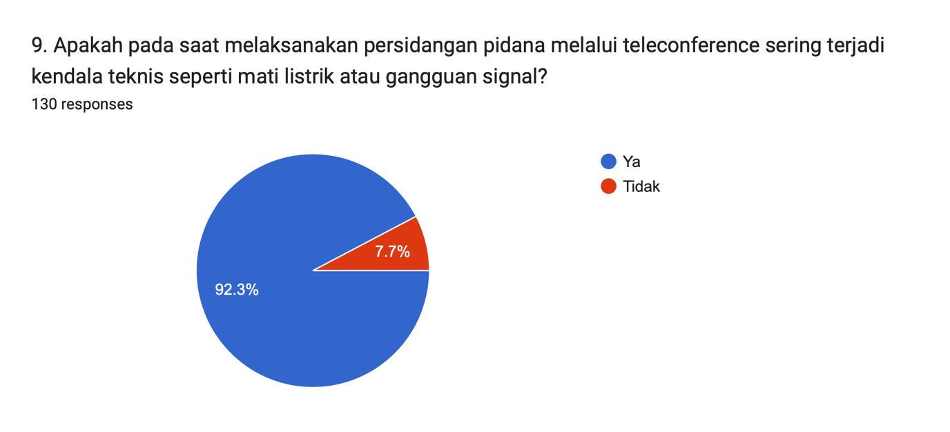
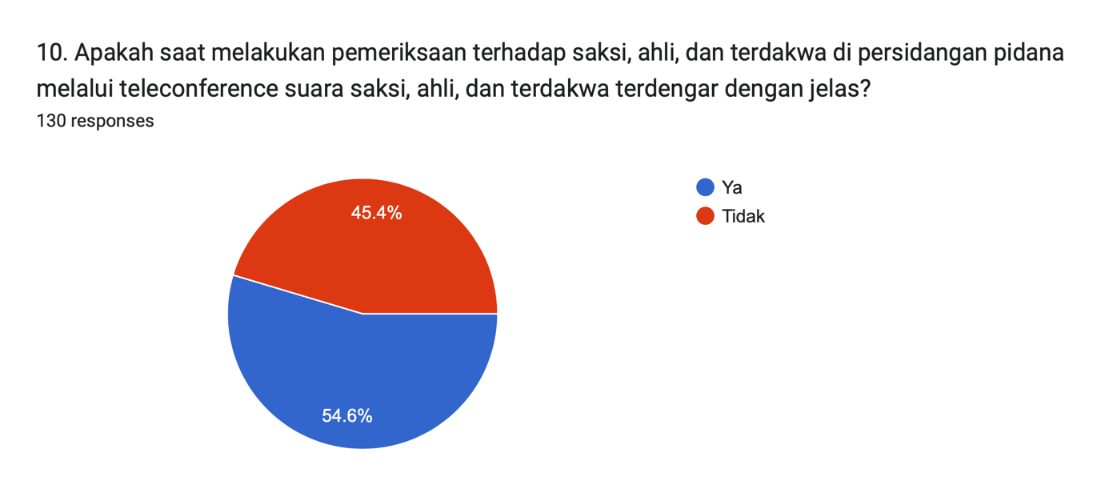

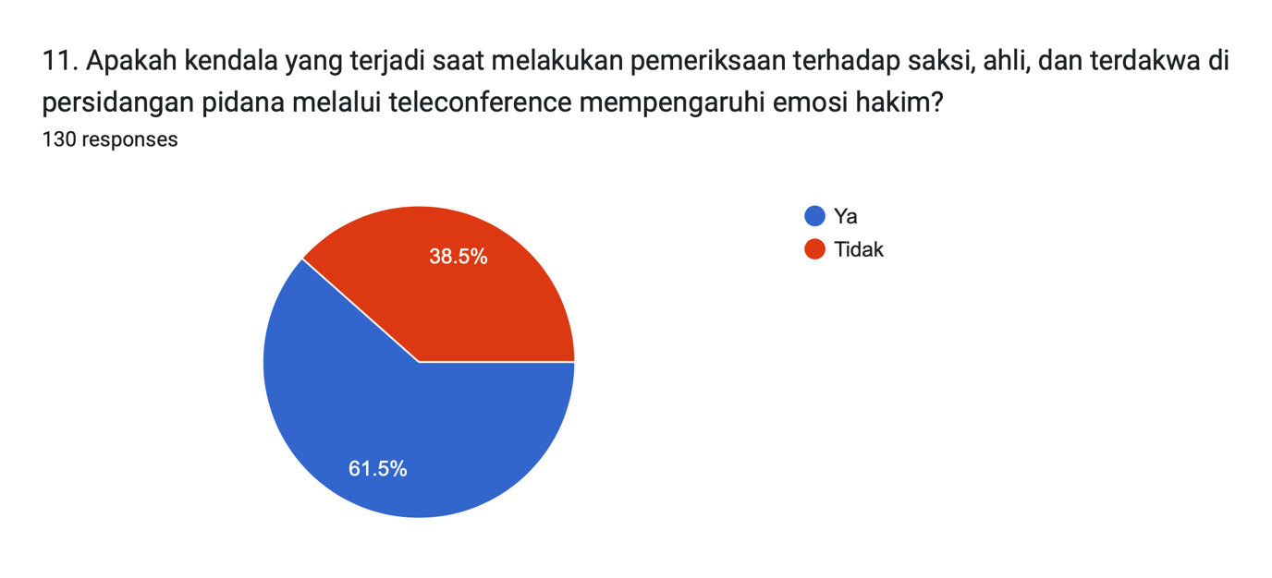
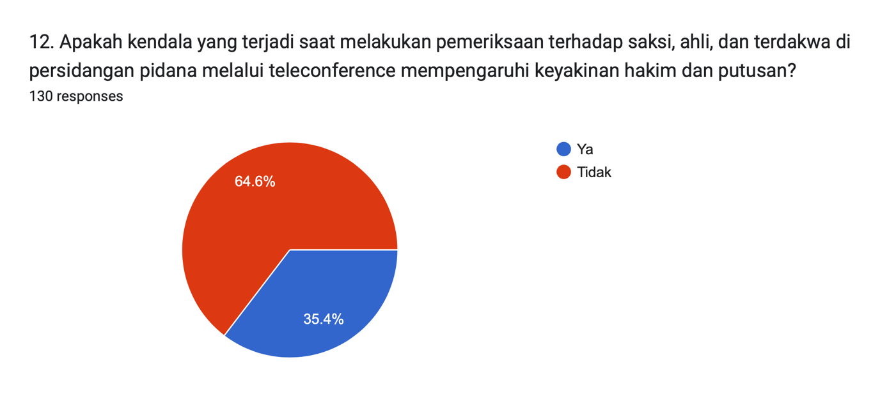

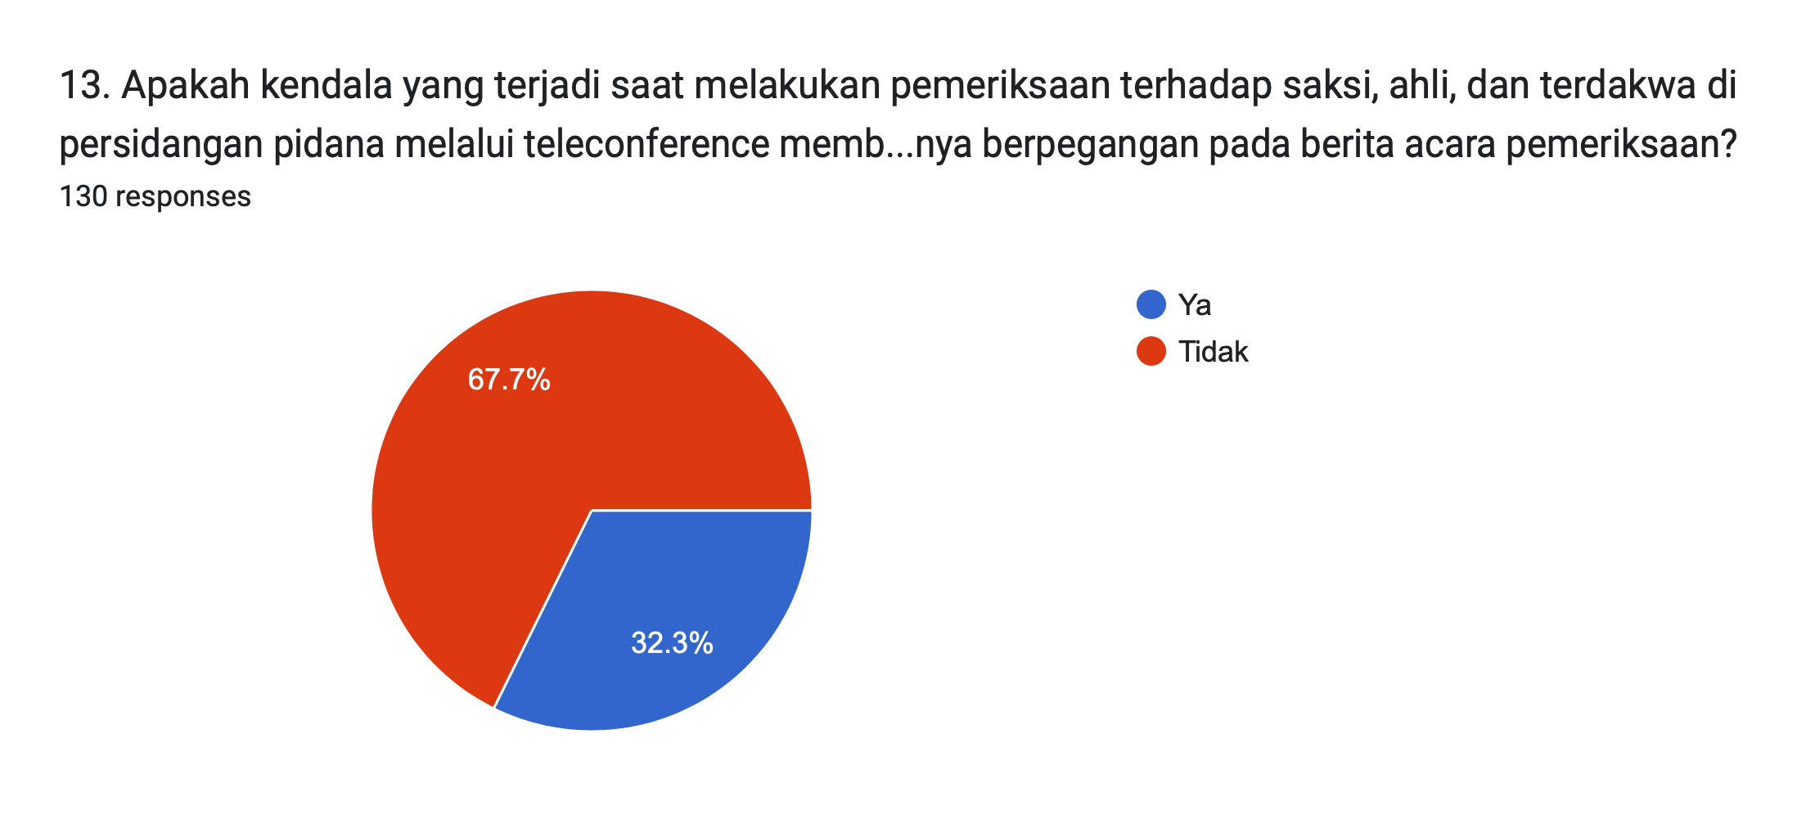

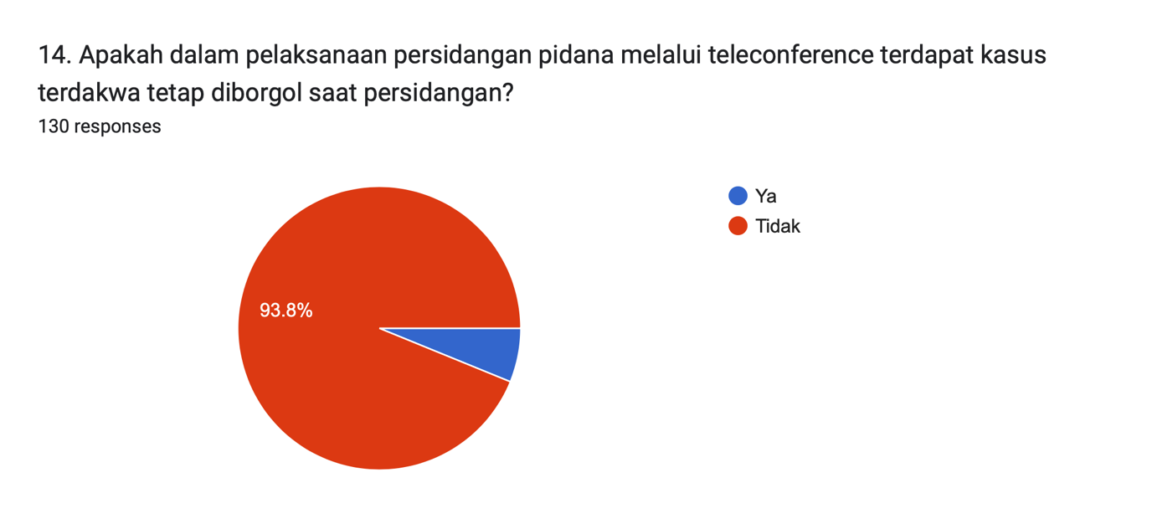

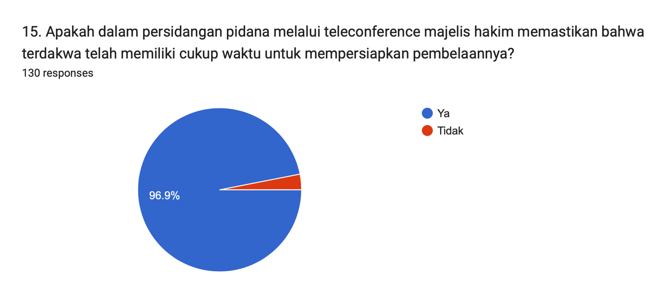

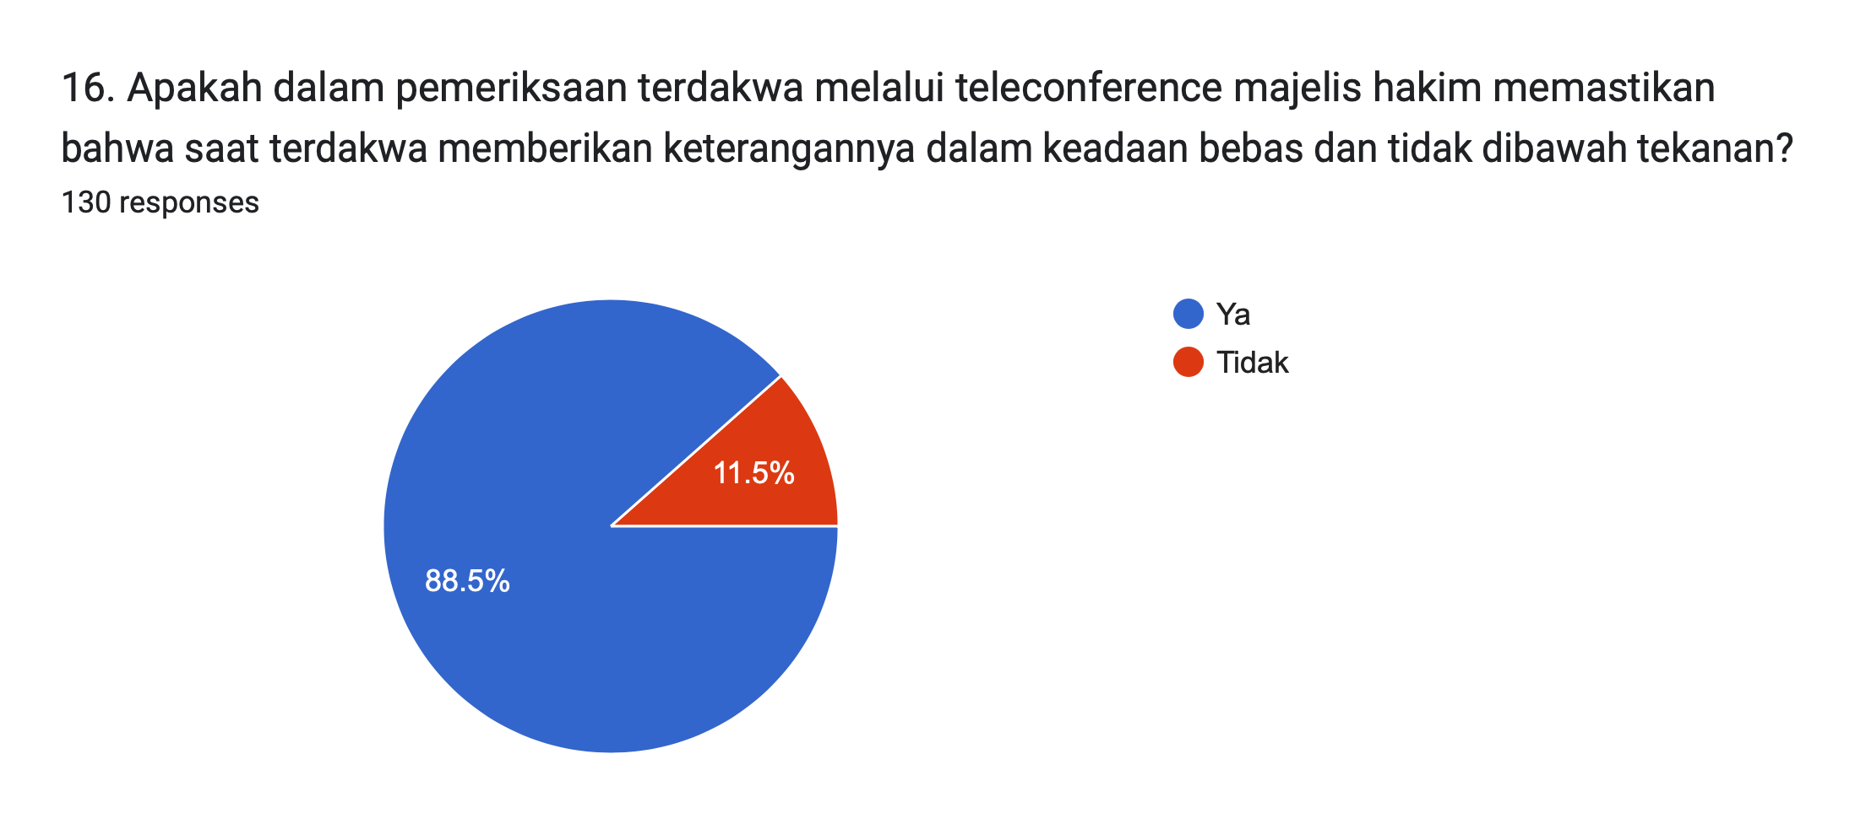

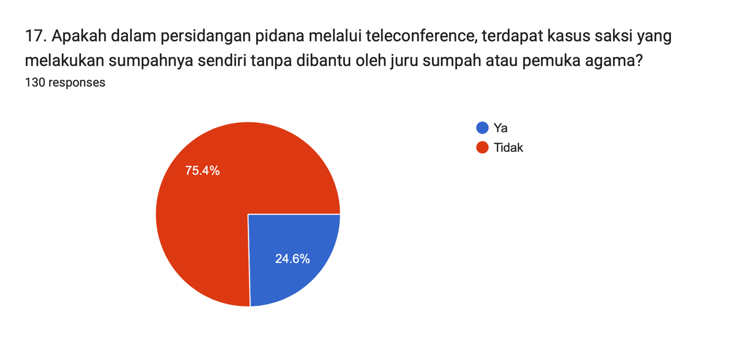

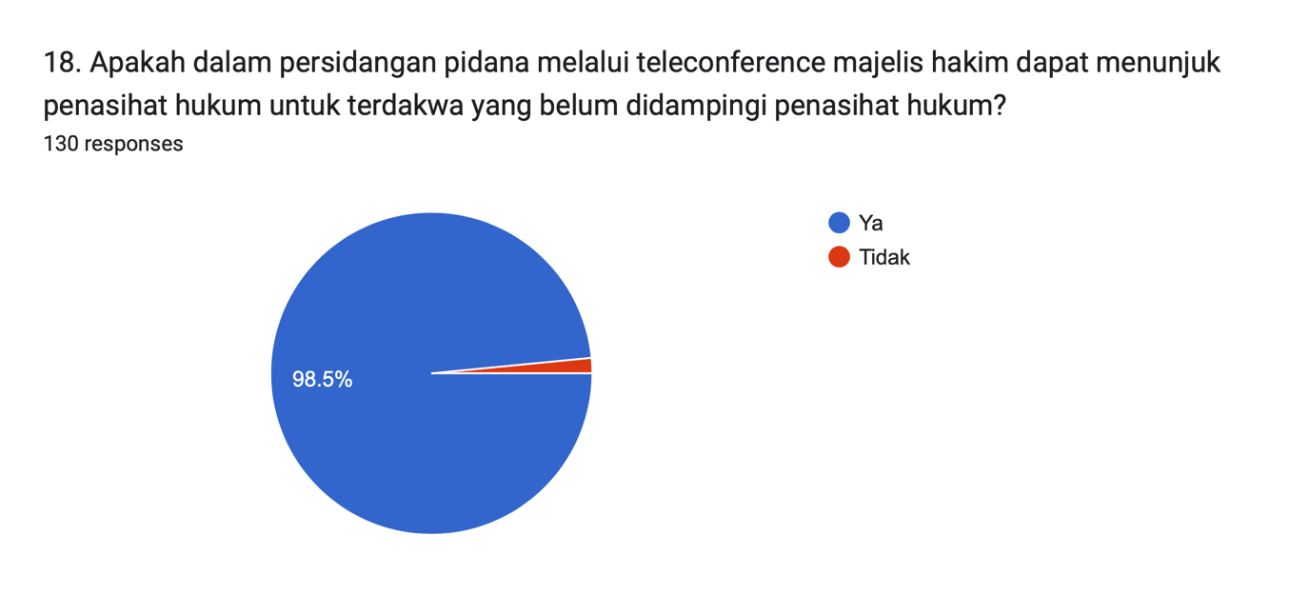

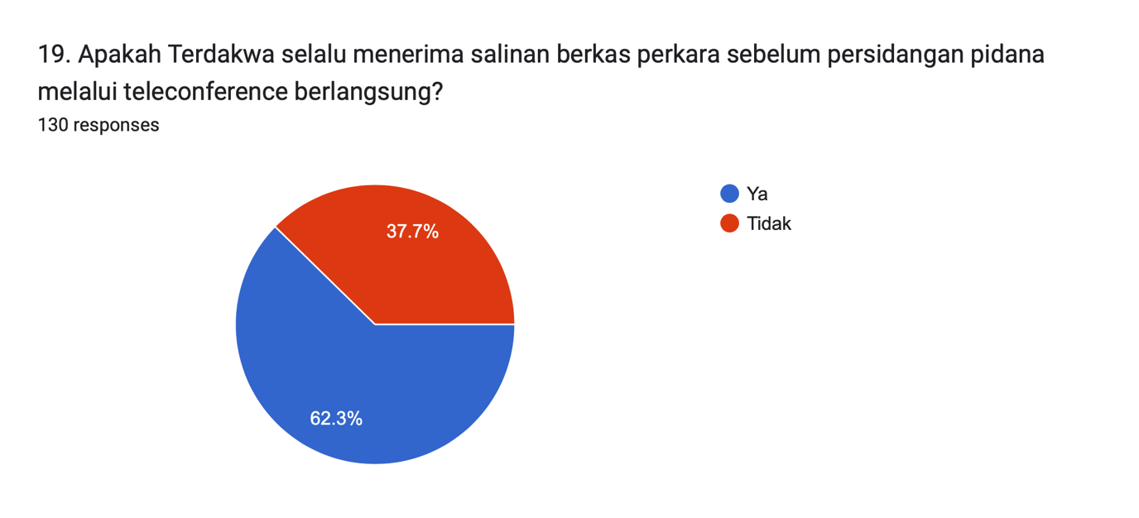

Written interview with Country Court Judges of Harju, Estonia.

- Is there any policy during the COVID-19 pandemic that the implementation all of criminal proceedings must be carried out through telehearing?

Government of Estonia firstly applied measures of emergency on March 13th, 2020 and they were in force until the end of May. https://www.riigiteataja.ee/en/eli/517032020005/consolide

Supreme Court and courts managements suggested more specific rules for court proceedings, which strongly recommended working from home, using tele-hearings etc technical solutions. As there are very few cases in criminal procedure law, which can be handled in written proceedings (less than 5 % of all criminal cases), most of the cases were carried out through telehearing.

The criminal procedure law (§69) prior to pandemic envisaged that telehearing can be organized to only to hear witness or victim (§ 69. Telehearing (1) A body conducting the proceedings may organise telehearing of a witness if the direct hearing of the witness is complicated or involves excessive costs or if it is necessary to protect the witness or the victim).

Also there was a restriction upon hearing witness by the phone, the defendant must agree with this type of hearing (§ 69 (3) Telehearing by telephone is permitted only with the consent of the person to be heard and the suspect or accused. The consent of the suspect or accused is unnecessary for the telehearing of anonymous witnesses by telephone. https://www.riigiteataja.ee/en/eli/507012020008/consolide)

Prior to pandemic having trials without a defendant present was only possible if he agreed to telehearing.

(§ 269. Participation of accused in judicial hearing
(1) A criminal matter shall be heard in the presence of the accused, taking into account the exceptions specified in this section and § 276¹ of this Code. If the accused fails to appear, judicial hearing shall be adjourned. Participation of the accused in the pronouncement of the court judgment is not mandatory.
[RT I, 23.02.2011, 1 - entry into force 01.09.2011]
(2) As an exception, a criminal matter may be heard in the absence of the accused if:
1) he or she has been removed from the courtroom on the basis and pursuant to the procedure provided for in subsection 267 (1) of this Code;
2) he or she has received the summons, his or her whereabouts cannot be established, there is sufficient reason to believe that he or she absconds court proceedings, reasonable efforts have been made for finding him or her, and the court hearing is possible without him or her;
[RT I, 20.12.2019, 1 - entry into force 30.12.2019]
3) after his or her interrogation at a court session, the accused has caused himself or herself to be in a state which precludes his or her participation in judicial hearing, and judicial hearing is possible without him or her;
4) it is complicated to take him or her to the court, and he or she has consented to participation in judicial hearing in audio-visual form pursuant to clause 69 (2) 1) of this Code;)

Ministry of Justice quickly drafted a law in order to change different of problems in different legal acts which actualized during first week of pandemic, this law, changing also Criminal Procedure acts regulation of telehearings entered in to force on May 7,2020.

New redaction of the law is as follows:

§ 69. Telehearing
(1) A body conducting the proceedings may organise telehearing if the direct hearing of a person is complicated or unreasonably burdensome or if telehearing is necessary to protect the interests of the person.
[ RT I, 06.05.2020, 1 - entry into force 07.05.2020]
(2) For the purposes of this Code, telehearing means hearing:
1) by means of a technical solution, as a result of which the testimony of the person heard is seen and heard directly via live coverage and he or she can be asked questions;
2) by phone, as a result of which the testimony of the person is immediately heard and he or she can be asked questions.
[ RT I, 06.05.2020, 1 - entry into force 07.05.2020]
(3) [Repealed - RT I, 06.05.2020, 1 - entry into force 07.05.2020].
(4) The minutes of a telehearing shall contain a notation that the witness has been warned against refusal to give testimony without a legal basis and giving knowingly false testimony.
(5) The provisions of § 489⁴¹ of this Code apply to hearing of persons staying in a foreign state, in co-operation between the Member States of the European Union, and in other cases the provisions of § 468 of this Code.
[ RT I, 06.05.2020, 1 - entry into force 07.05.2020]
(6) The minister responsible for the area may establish more specific requirements for organising telehearing.
[RT I 2004, 46, 329 - entry into force 01.07.2004]

Also by this legal act, a new instrument was implemented in Criminal Procedure law –written testimony, but this concern only pre-trial investigation phase.

( § 69². Written testimony (1) In pre-trial procedure, a body conducting proceedings may require a witness to provide written answers to the questions posed within the term prescribed by the body conducting the proceedings if the body conducting the proceedings finds that direct or telehearing is not practicable.)

Also was regulated that interpreter can participate via videoconference

(§ 161. Translators and interpreters. (1) If a text in a foreign language needs to be translated or interpreted or if a participant in a criminal proceeding is not proficient in Estonian, a translator or interpreter shall be involved in the proceeding. Participation of an interpreter in a procedural act or court session may be arranged by means of any technical solutions which comply with the requirements specified in subsection 69 (2) of this Code.)

In regulations, concerning defendant’s participation in court proceedings a change was also made to the Criminal Procedure law, erasing the demand of defendant agreement:

(§ 269. Participation of accused in judicial hearing
(1) A criminal matter shall be heard in the presence of the accused, taking into account the exceptions specified in this section and § 276¹ of this Code. If the accused fails to appear, judicial hearing shall be adjourned. Participation of the accused in the pronouncement of the court judgment is not mandatory.
[RT I, 23.02.2011, 1 - entry into force 01.09.2011]
(2) As an exception, a criminal matter may be heard in the absence of the accused if:
1) he or she has been removed from the courtroom on the basis and pursuant to the procedure provided for in subsection 267 (1) of this Code;
2) he or she has received the summons, his or her whereabouts cannot be established, there is sufficient reason to believe that he or she absconds court proceedings, reasonable efforts have been made for finding him or her, and the court hearing is possible without him or her;
[RT I, 20.12.2019, 1 - entry into force 30.12.2019]
3) after his or her interrogation at a court session, the accused has caused himself or herself to be in a state which precludes his or her participation in judicial hearing, and judicial hearing is possible without him or her;
4) it is complicated to take him or her to the court, and the accused can participate in the court hearing by means of any technical solutions which comply with the requirements specified in clause 69 (2) 1) of this Code, and the court is convinced that the right of defence of the accused is ensured; [ RT I, 06.05.2020, 1 - entry into force 07.05.2020])

- Is there any rejection from the public especially from the defendant and their counsel in conducting criminal proceedings through telehearing?
Prior to the changes of the procedural law, there has been few cases where defendants did not agree to the telehearing, also some cases of defendants not able to connect through telehearing, because they do not have suitable technology. Few cases were also such where an issue of right to defense was argued, in view, that defense council and defendant are not in the same room and cannot instantly converse with each other in private. As it was allowed by state of emergence rules, that two people can be together if they use personal protective equipment (PPE), these situations were resolved so that the defendant who did not have computer could go to defense lawyers’ office to participate in telehearing with lawyer, or if that was not possible, the defendant and lawyer came to the court.

- If there is any rejection from public in conducting criminal proceedings through telehearing, did the court grant the refusal?
In case the defendant was in prison and they argued a case of depriving the right to defense and prisons did not allow visitors, the cases where postponed until it was possible to transfer defendants from prison to courthouse. It lasted two weeks, within which period the police started to transfer prisoners from prison to court.

- Do the prosecutor, defendant and their legal counsel still come to the court when criminal trial are carried out through telehearing?
Since May 7, it is possible, that everyone works from distance, even judge and court session secretary, but most of the judges still prefer to run the hearings from courthouse. So usually there are in courtroom judge and secretary. In bigger cases there are more difficult to organize telehearing, so it is decided case-by-case, who can participate via telehearing and who must be at courthouse.

- Is the criminal trial through telehearing only carried out on the hearing of witness and expert or can it be implemented for all of the court session?
Basically the court hearings can all be in telehearing, but in general proceedings all the evidence must be handed to court during court session (all written evidence, documents etc), and this is not possible to do through telehearing, so this cases are mostly handled in court sessions. There are only less than 10 % of hearings general proceedings, most cases are dealt with in alternative proceedings (settlement, alternative or summary procedure), which can be dealt via telehearing.

- Was a criminal trial through telehearing also conducted for the examination of the accused?
Yes, this is possible by the law.

- How is the procedure for taking the oath of witness in criminal trial through out telehearing?
The minutes of a telehearing shall contain a notation that the witness has been warned against refusal to give testimony without a legal basis and giving knowingly false testimony.

- How is the implementation of public access in criminal trial through telehearing?
Public access to hearing is an issue, but there has not been any mayor discussion on this subject. I myself in a case of large public interest sent to journalists who were interested in writing about the case, information (a link) how to join the telehearing and they also were able to hear the reading of courts decision through telehearing.

- Is the all court file sent by the E-File System?
Yes, all court documents are sent by E-file to a person whom it concerns (eg the summons to the defendant, but other documents to all participants. Defense lawyer, prosecutor, defendant, victims have access to all the documentation of the case and it is seen, when person has received a document. I´ll attach a screenshot from E-file system. There is a court’s decision sent to defendant and defense lawyer on 18.12.2020 and on down right hand said there is automatically generated time when the defense lawyer opened the file (29.12.2020 11:53). The same is with any other document.
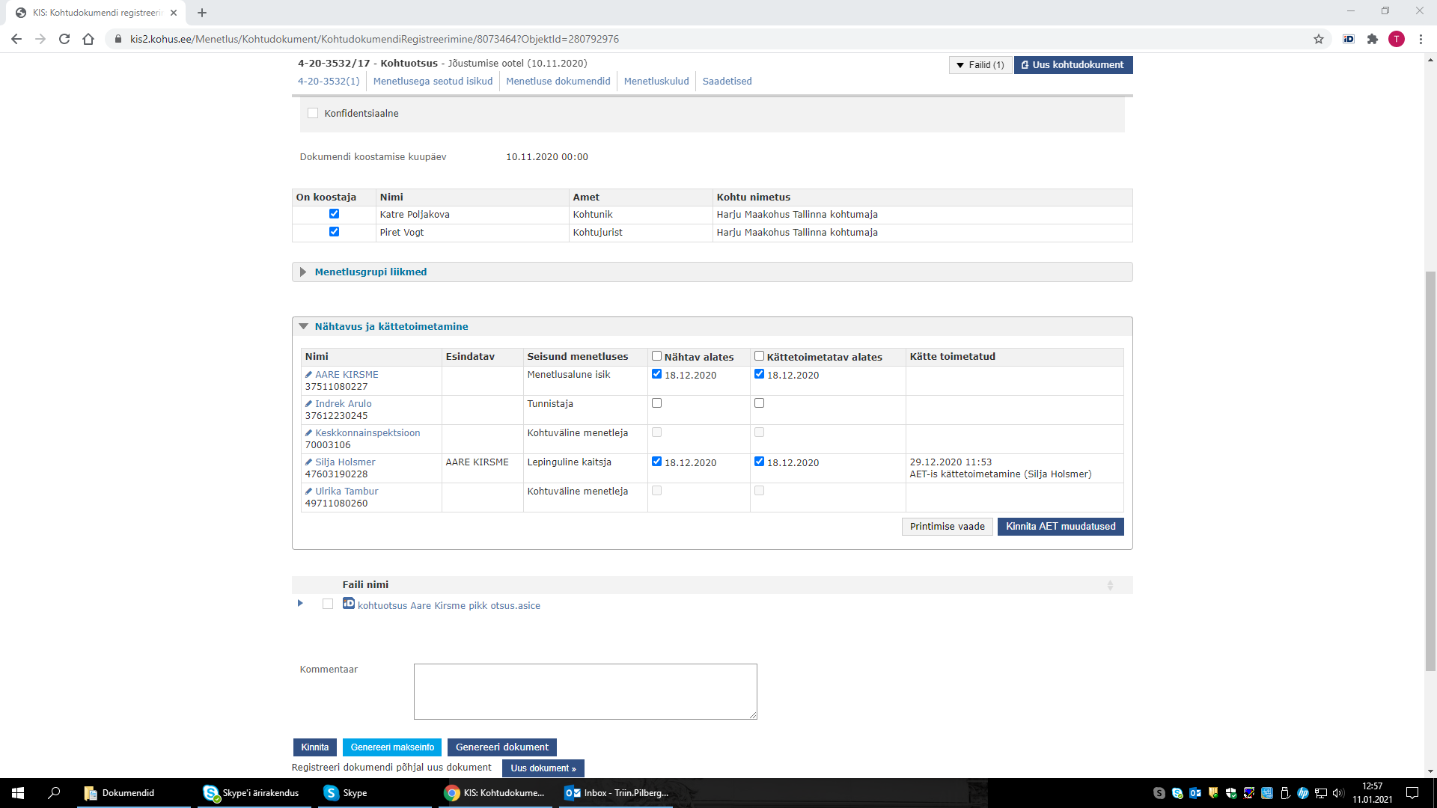

- Is the defendant could still meet their counsel to prepare their defense when the criminal trial through by telehearing during the pandemic? or the defendant given facilities to communicate with their legal counsel to prepare their defense?
Yes, they can meet. Either in prison or in lawyer’s office. The pre-trial investigative file is not yet fully digital, but paper evidence is digitalized (scanned) by the prosecutor’s office and handed to defense lawyer in .pdf format. Prison has computers with no internet access in order to defense lawyer to show evidence of the case to defendant.

- What is the difficulties and obstacles in conducting criminal proceedings through telehearing?
Difficulties have mostly been of technical nature, slow connections etc. No mayor setbacks.

- Do the opening statement, hearing of the charges, opinion from defendant or counsel for the charges carried out via technical hearing or adjudication with written proceeding?
Yes, all those parts of general proceeding can be handled in telehearings, also witness statements.
As a conclusion, few words about our court, Harju County Court in Tallinn, capital of Estonia is the biggest first instance court in Estonia, which deals more than 40% of all criminal cases in Estonia. We have 66 judges from whom 22 are specialized to criminal matters.
It must be mentioned that efficacy of the court during first wave of pandemic (mid-March to June) did not drop drastically, or in fact did not drop at all.
 | 2018.a | 2019.a | 2020.a
 | 2018.a | 2019.a | 31.01. | 29. 02. | 31.03. | 30.04. | 31.05. | 30.06. | 31.08. | 30.09. | 31.10. | 30.11. | 31.12.
Tsiviilasjad
Jõudlus aruandeaastal (%) | 99,3% | 95,2% | 104,0% | 108,1% | 106,2% | 106,5% | 106,3% | 104,0% | 99,8% | 101,4% | 101,3% | 100,9% | 99,3%
Saabunud asjade arv | 14466 | 16048 | 1465 | 2659 | 4140 | 5466 | 6803 | 8299 | 10892 | 12261 | 13673 | 15162 | 16682
Lahendatud asjade arv | 14364 | 15276 | 1523 | 2874 | 4398 | 5822 | 7234 | 8629 | 10866 | 12438 | 13851 | 15300 | 16558
Jõudlus alates 2018.a |  |  | 95,9% | 97,0% | 97,5% | 98,1% | 98,5% | 104,0% | 97,0% | 97,9% | 98,0% | 98,0% | 97,3%
Jõudlus alates 2017.a |  |  | 97,4% | 98,0% | 98,2% | 98,6% | 98,8% | 98,6% | 97,8% | 98,4% | 98,4% | 98,4% | 97,9%
Criminal cases
Efficacy (%) | 98,0% | 100,7% | 99,8% | 101,1% | 98,6% | 96,8% | 98,3% | 100,0% | 95,9% | 98,7% | 97,9% | 98,6% | 99,2%
Cases sent to the court | 6275 | 6168 | 539 | 959 | 1391 | 1760 | 2241 | 2752 | 3733 | 4248 | 4854 | 5474 | 5958
Decided cases | 6152 | 6213 | 538 | 970 | 1372 | 1704 | 2204 | 2752 | 3580 | 4192 | 4752 | 5398 | 5909
Jõudlus alates 2018.a |  |  | 100,7% | 100,8% | 100,3% | 99,9% | 100,1% | 100,0% | 98,9% | 99,9% | 99,5% | 99,7% | 100,0%
Jõudlus alates 2017.a |  |  | 99,4% | 99,5% | 99,3% | 99,1% | 99,2% | 99,5% | 98,6% | 99,2% | 99,0% | 99,1% | 99,3%

Written interview with Country Court Judges of Pärnu, Estonia.

- Is there any policy during the COVID-19 pandemic that the implementation all of criminal proceedings must be carried out through telehearing?
There was no mandatory policy during the Covid-19 pandemic but it was recommended that we should carry out as many criminal proceedings through telehearing as possible. In Estonia the Code of Criminal Procedure provides that court may organise the participation of the parties to judicial proceedings in the judicial hearing by technical solution and we practice it on a daily basis.
- Is there any rejection from the public especially from the defendant and their counsel in conducting criminal proceedings through telehearing?
There was no rejection from public. Defendants and counsels always agreed to carry out proceedings through telehearing if it was technically possible for them.
- If there is any rejection from public in conducting criminal proceedings through telehearing, did the court grant the refusal?
If the parties of the proceedings had reasonable excuses then if it was possible court postponed the hearing. If it was necessary to carry out the hearing on that day then court asked the parties to come to the courthouse. Then the court session was held in a big courtroom.
- Do the prosecutor, defendant and their legal counsel still come to the court when criminal trial are carried out through telehearing?
If it was not technically possible for the parties to join the telehearing on their own then they came to the court.
- Is the criminal trial through telehearing only carried out on the hearing of witness and expert or can it be implemented for all of the court session?
It depends on the type of the court proceedings. Big proceedings are not fully carried out through telehearings but if witnesses and experts want to join through telehearing then it is possible.
- Was a criminal trial through telehearing also conducted for the examination of the accused?
Although it is technically and legally possible, we did not conduct the examination of the accused through telehearing.

- How is the procedure for taking the oath of witness in criminal trial through out telehearing?
Before the hearing, we send the oath of witness to the witness by e-mail or by mail. When the hearing is carried out the judge identifies the witness through the national database and then judge warns the witness and witness signs the oath digitally or physically. After the hearing the witness sends signed oath back to court by e-mail or by mail.
- How is the implementation of public access in criminal trial through telehearing?
Usually judge and the secretary joined the telehearings while being in the courthouse, but there were also court sessions where everybody was at their homes and joined session through computer virtual space. So if there was any public interest, then everybody had the opportunity to join the criminal trial in the courthouse or via virtual space.
- Is the all court file sent by the E-File System?
Court always sends out all court files to counsels and prosecutors by the E-File System. Although we do not always send all court files to defendants and other parties of the proceedings by e-mail, they still can see all court documents through the E-File System by using their ID card.
- Is the defendant could still meet their counsel to prepare their defense when the criminal trial through by telehearing during the pandemic? or the defendant given facilities to communicate with their legal counsel to prepare their defense?
We can not answer this question because we do not know about this. You must contact a counsel (or Estonian Bar Association) to get this answer.
- What is the difficulties and obstacles in conducting criminal proceedings through telehearing?
Usually there was no difficulties or obstacles because mostly everybody has a smart phone or a computer these days. In some cases parties of the proceedings had problems with their Internet (for example the speed of Internet was poor) and sometimes telehearing systems were overloaded.
- Do the opening statement, hearing of the charges, opinion from defendant or counsel for the charges carried out via technical hearing or adjudication with written proceeding?
In criminal proceedings opening statement, hearing of the charges, opinion from defendant or counsel were never carried out with written proceedings.

